SIMATS ENGINEERING
ASSESSMENT TOOL 3
COURSE NAME: Database Management Systems
COURSE CODE: CSA05
NAME: J Jaslin Jeba Thurai
Reg NO: 192321175
COURSE OUTCOME COVERED
CO2: Apply the relational model, relational algebra, SQL query structures, and views to solve database querying and data manipulation problems. (BL3, BL6)
Activity Tool : Debugging & Optimisation Task (Low)
Assessment Tool Weightage: 30%
QUESTIONS Total Marks: 50
Q.No | Question | Bloom's Level | Marks
1 | Identify and fix the error in the given SQL query that uses incorrect JOIN syntax and returns duplicate results. | BL3 – Apply | 5
2 | The following sub-query returns incorrect results due to a missing correlation. Debug and rewrite it correctly. | BL3 – Apply | 5
3 | A given SQL view definition causes errors when queried. Identify the issue and rewrite a correct and optimized view. | BL3 – Apply | 5
4 | Debug the given relational algebra expression that produces incorrect output for a natural join operation. | BL3 – Apply | 5
5 | The SQL query below violates referential integrity. Identify the violation and modify the statements to enforce proper constraints. | BL3 – Apply | 5
6 | Given an inefficient SQL query with nested loops, rewrite it using JOIN to optimize performance. | BL6 – Create | 5
7 | The GROUP BY query below produces wrong aggregation results. Debug the query and explain the error. | BL3 – Apply | 5
8 | Identify and fix the logical error in a given SQL UPDATE statement that unintentionally modifies all rows in the table. | BL3 – Apply | 5
9 | Optimize the given multi-table SQL query by restructuring sub-queries into JOINs and using appropriate indexes. | BL6 – Create | 5
10 | Debug a given relational calculus expression that returns an empty result set due to incorrect quantifier usage. | BL3 – Apply | 5

Code of Conduct:
I J jaslin/192321175 (Name / Reg No) certify that this submission is my original work and that I have adhered to the guidelines specified for this assessment.
I understand that any violation of academic integrity rules will result in disciplinary action.
Signature of the student:
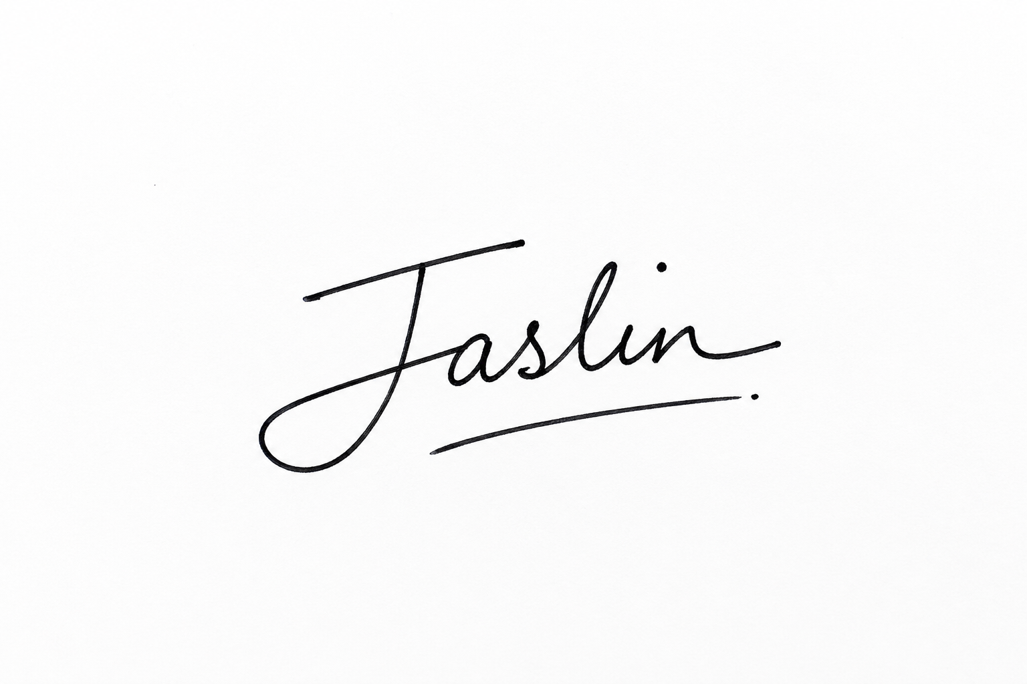
RUBRICS FOR CALCULATION:
Criteria | Weightage | Level 4 (Exemplary) | Level 3 (Proficient) | Level 2 (Developing) | Level 1 (Beginning)
Problem Identification | 20% | Accurately identifies all errors and root causes with clear understanding | Identifies most errors with minor gaps | Identifies some errors but misses key issues | Unable to identify errors correctly
Debugging | 25% | Applies systematic debugging techniques effectively to resolve issues | Uses appropriate debugging methods with minor errors | Limited debugging approach; requires guidance | Unable to debug or resolve issues
Optimization | 20% | Optimizes code by significantly improving time complexity using efficient algorithms | Improves time complexity with minor gaps in efficiency | Limited improvement in time complexity | No improvement; inefficient approach retained
Analysis | 20% | Demonstrates strong logical reasoning and clear justification of solutions | Shows reasonable analysis with some justification | Limited analysis; weak reasoning | No analytical reasoning demonstrated
Code Quality | 15% | Produces clean, well-structured code with proper comments and documentation | Code is mostly clear with minor documentation gaps | Code lacks structure and proper documentation | Poorly written code with no documentation

Answer 1: Incorrect JOIN Syntax Causing Duplicate Results
Buggy query:
SELECT E.Name, D.DeptName
FROM Employee E, Department D;
-- Missing join condition: this is an implicit Cartesian product,
-- so every employee row is paired with every department row.

Diagnosis:
• The old-style comma join has no WHERE/ON condition linking E.DeptID to D.DeptID, so SQL performs a full Cartesian product (every employee × every department) instead of matching related rows — this is what produces the duplicate/incorrect result set.
Corrected query:
SELECT E.Name, D.DeptName
FROM Employee E
JOIN Department D ON E.DeptID = D.DeptID;

• Using explicit JOIN ... ON syntax forces a matching condition, so each employee is paired only with their own department, eliminating the duplicate/unmatched combinations.
Answer 2: Sub-query With Missing Correlation
Buggy query:
-- Intent: employees earning more than their OWN department's average
SELECT Name FROM Employee E1
WHERE Salary > (SELECT AVG(Salary) FROM Employee);
-- The sub-query ignores E1 entirely, so it computes ONE overall
-- average across ALL employees, not a per-department average.

Diagnosis:
• The sub-query is not correlated to the outer query — it never references E1.DeptID — so every outer row is compared against the same company-wide average salary instead of its own department's average, giving incorrect results.
Corrected query:
SELECT Name FROM Employee E1
WHERE Salary > (
SELECT AVG(E2.Salary) FROM Employee E2
WHERE E2.DeptID = E1.DeptID
);

• Adding WHERE E2.DeptID = E1.DeptID correlates the sub-query to the current outer row, so it is re-evaluated per employee against only their own department's rows.
Answer 3: SQL View Causing Errors When Queried
Buggy view:
CREATE VIEW DeptSummary AS
SELECT D.DeptName, COUNT(*), E.Salary
FROM Employee E
JOIN Department D ON E.DeptID = D.DeptID
GROUP BY D.DeptName;
-- E.Salary appears in SELECT but is neither aggregated nor part of
-- the GROUP BY list -> functional-dependency / ONLY_FULL_GROUP_BY error.

Diagnosis:
• Every non-aggregated column in the SELECT list of a GROUP BY query must appear in the GROUP BY clause. E.Salary is neither grouped nor wrapped in an aggregate function, so the database engine rejects the view (or, on lenient engines, returns an arbitrary/incorrect Salary per group).
Corrected, optimized view:
CREATE VIEW DeptSummary AS
SELECT D.DeptName,
COUNT(*) AS EmpCount,
AVG(E.Salary) AS AvgSalary
FROM Employee E
JOIN Department D ON E.DeptID = D.DeptID
GROUP BY D.DeptName;

• Salary is now wrapped in AVG(), an aggregate consistent with the GROUP BY, resolving the error and giving a meaningful per-department figure. Aliasing the aggregate columns (EmpCount, AvgSalary) also makes the view self-documenting for anyone querying it.
Answer 4: Relational Algebra Natural Join Producing Incorrect Output
Buggy expression:
Employee ⋈ (Employee.DeptID = Department.DeptNo) Department
-- Department has no attribute named 'DeptNo' — its primary key
-- attribute is 'DeptID'. The join condition references a
-- non-existent attribute.

Diagnosis:
• A join (natural or theta) condition must compare attributes that actually exist in the operand relations. Referencing Department.DeptNo when the real attribute is Department.DeptID means the condition can never be satisfied correctly — depending on the system this either errors out or silently returns zero/incorrect rows.
Corrected expression:
Employee ⋈ (Employee.DeptID = Department.DeptID) Department

• Correcting the attribute name to Department.DeptID matches it against Employee.DeptID as intended, so the join returns exactly the employee rows combined with their correct matching department row.
• For a true natural join (⋈ without an explicit condition), both relations should simply share an identically-named join attribute (DeptID in both), letting the system match on it automatically.
Answer 5: SQL Violating Referential Integrity
Buggy schema and statement:
CREATE TABLE Orders (
OrderID INT PRIMARY KEY,
CustomerID INT, -- no FOREIGN KEY constraint declared
OrderDate DATE
);

INSERT INTO Orders VALUES (1, 999, '2026-01-01');
-- CustomerID 999 does not exist in Customer, but since there is
-- no FK constraint, the insert succeeds and integrity is violated.

Diagnosis:
• CustomerID in Orders is meant to reference Customer, but no FOREIGN KEY constraint enforces that relationship, so the database silently accepts orders pointing to customers that don't exist — a referential integrity violation.
Corrected schema:
CREATE TABLE Orders (
OrderID INT PRIMARY KEY,
CustomerID INT NOT NULL,
OrderDate DATE,
CONSTRAINT fk_orders_customer FOREIGN KEY (CustomerID)
REFERENCES Customer(CustomerID)
ON DELETE RESTRICT
ON UPDATE CASCADE
);

-- The same insert now fails unless CustomerID 999 exists in Customer:
INSERT INTO Orders VALUES (1, 999, '2026-01-01'); -- rejected

• Adding the FOREIGN KEY constraint forces every CustomerID in Orders to match an existing Customer.CustomerID, so invalid references are rejected at insert/update time instead of silently corrupting the data.
Answer 6: Inefficient Nested-Loop Query Rewritten as JOIN
Inefficient query (correlated scalar sub-query per row — effectively a nested loop):
SELECT E.Name,
(SELECT D.DeptName FROM Department D
WHERE D.DeptID = E.DeptID) AS DeptName
FROM Employee E;
-- The scalar sub-query is re-executed once for every row of Employee
-- (an implicit nested loop), which is costly on large tables.

Diagnosis:
• Running a separate Department lookup per Employee row scales poorly — the optimizer must repeat a scan/lookup on Department for every outer row (O(n×m) in the worst case) instead of processing both tables in a single set-based pass.
Optimized query:
SELECT E.Name, D.DeptName
FROM Employee E
JOIN Department D ON E.DeptID = D.DeptID;

• A single JOIN lets the query optimizer choose an efficient join strategy (e.g., hash join or index-based lookup) processed once over both tables, rather than one sub-query execution per outer row.
• Adding an index on Department.DeptID (already the primary key here) and Employee.DeptID further speeds up the join.
Answer 7: GROUP BY Query Producing Wrong Aggregation
Buggy query:
-- Intent: total salary paid out per department
SELECT DeptID, SUM(Salary) AS TotalSalary
FROM Employee
GROUP BY EmpID;
-- Grouped by EmpID instead of DeptID, so each group contains only
-- a single employee -> SUM just returns each employee's own salary.

Diagnosis:
• The query groups by EmpID (which is unique per row) instead of DeptID, so SUM(Salary) is computed over groups of exactly one row each — it never actually aggregates salaries across a department, defeating the purpose of the report.
Corrected query:
SELECT DeptID, SUM(Salary) AS TotalSalary
FROM Employee
GROUP BY DeptID;

• Grouping by DeptID correctly collects all employees belonging to the same department into one group before SUM is applied, producing one true total per department.
Answer 8: UPDATE Statement Unintentionally Modifying All Rows
Buggy statement:
-- Intent: give a 10% raise only to Department 5
UPDATE Employee
SET Salary = Salary * 1.10;
-- Missing WHERE clause -> every row in Employee gets the raise,
-- not just Department 5.

Diagnosis:
• An UPDATE with no WHERE clause applies to every row in the table by definition. The logical error here is the omission of the filter that was meant to restrict the raise to a specific department.
Corrected statement:
UPDATE Employee
SET Salary = Salary * 1.10
WHERE DeptID = 5;

• Adding WHERE DeptID = 5 restricts the update to only the intended rows.
• As a general safeguard, running the equivalent SELECT (SELECT * FROM Employee WHERE DeptID = 5) first to confirm the affected rows before executing the UPDATE helps catch this class of error earlier.
Answer 9: Optimizing a Multi-Table Query (Sub-queries → JOINs + Indexes)
Unoptimized query:
SELECT Name FROM Employee
WHERE DeptID IN (SELECT DeptID FROM Department WHERE Location='Chennai')
AND EmpID IN (SELECT EmpID FROM Project WHERE Status='Active');
-- Two independent IN sub-queries are evaluated separately, and
-- without supporting indexes each is effectively a full table scan.

Diagnosis:
• Each IN sub-query is planned and executed largely independently of the outer query, and with no indexes on Department.Location or Project.Status/EmpID, the engine must scan those tables in full for every execution.
Optimized query using JOINs:
SELECT DISTINCT E.Name
FROM Employee E
JOIN Department D ON E.DeptID = D.DeptID AND D.Location = 'Chennai'
JOIN Project P ON E.EmpID = P.EmpID AND P.Status = 'Active';

Supporting indexes:
CREATE INDEX idx_department_location ON Department(Location);
CREATE INDEX idx_project_status_emp ON Project(Status, EmpID);
CREATE INDEX idx_employee_deptid ON Employee(DeptID);

• Rewriting the IN sub-queries as JOINs lets the optimizer build a single efficient execution plan (e.g., choosing hash or index-nested-loop joins) instead of evaluating each filter in isolation.
• The added indexes let the engine seek directly to matching Department/Project rows rather than scanning them fully; DISTINCT guards against duplicate Employee rows if a matching employee has more than one active project.
Answer 10: Relational Calculus Expression Returning Empty Result Due to Wrong Quantifier
Buggy expression:
-- Intent: employees who work on at least one project in the 'IT' department
{ t | t ∈ Employee ∧
∀ p ( p ∈ Project ∧ p.EmpID = t.EmpID ⟹ p.DeptID = 'IT' ) }

Diagnosis:
• The universal quantifier ∀ requires that EVERY project an employee is assigned to be in 'IT' — an employee who has even one project outside IT is excluded, and an employee with zero projects satisfies it vacuously (which is meaningless here). This is the wrong quantifier for "at least one", and combined with typical data it yields an empty or nonsensical result set instead of the intended list of employees who have any IT project.
Corrected expression:
{ t | t ∈ Employee ∧
∃ p ( p ∈ Project ∧ p.EmpID = t.EmpID ∧ p.DeptID = 'IT' ) }

• Replacing ∀ with the existential quantifier ∃ correctly expresses "there exists at least one project p belonging to this employee whose department is IT", matching the intended meaning of the query.
• As a rule of thumb: "at least one / some" maps to ∃, while "for every / all" maps to ∀ — misusing one for the other is the most common source of empty or over-restrictive calculus results.

